***This is a bonus Web chapter

CHAPTER 37

Containers, Layout Managers, and Borders

Objectives
- To explore the internal structures of the Swing container (§37.2).
- To explain how a layout manager works in Java (§37.3).
- To use CardLayout and BoxLayout (§§37.3.1-37.3.2).
- To use the absolute layout manager to place components in the fixed position (§37.3.3).
- To create custom layout managers (§37.4).
- To use JScrollPane to create scroll panes (§37.5).
- To use JTabbedPane to create tabbed panes (§37.6).
- To use JSplitPane to create split panes (§37.7).
- To use various borders for Swing components (§37.8).
37.1 Introduction
<margin note: container>
<margin note: layout manager>
Chapter 12, “GUI Basics,” introduced the concept of containers and the role of layout managers. You learned how to add components into a container and how to use FlowLayout, BorderLayout, and GridLayout to arrange components in a container. A container is an object that holds and groups components. A layout manager is a special object used to place components in a container. Containers and layout managers play a crucial role in creating user interfaces. This chapter presents a conceptual overview of containers, reviews the layout managers in Java, and introduces several new containers and layout managers. You will also learn how to create custom layout managers and use various borders.

37.2 Swing Container Structures
User interface components like JButton cannot be displayed without being placed in a container. A container is a component that holds other components. You do not display a user interface component; you place it in a container, and the container displays the components it contains.

The base class for all containers is java.awt.Container, which is a subclass of java.awt.Component. The Container class has the following essential functions:

- It adds and removes components using various add and remove methods.
- It maintains a layout property for specifying a layout manager that is used to lay out components in the container. Every container has a default layout manager.
- It provides registration methods for the java.awt.event.ContainerEvent.
In AWT programming, the java.awt.Frame class is used as a top-level container for Java applications, the java.awt.Applet class is used for all Java applets, and java.awt.Dialog is used for dialog windows. These classes do not work properly with Swing lightweight components. Special versions of Frame, Applet, and Dialog named JFrame, JApplet, and JDialog have been developed to accommodate Swing components. JFrame is a subclass of Frame, JApplet is a subclass of Applet, and JDialog is a subclass of Dialog. JFrame and JApplet inherit all the functions of their heavyweight counterparts, but they have a more complex internal structure with several layered panes, as shown in Figure 37.1.
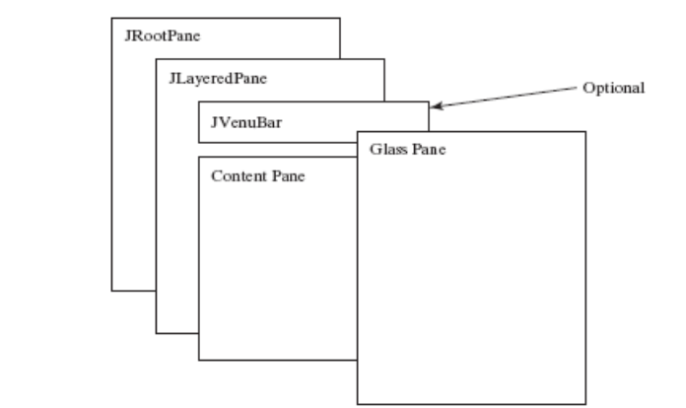

Figure 37.1
Swing top-level containers use layers of panes to group lightweight components and make them work properly.
javax.swing.JRootPane is a lightweight container used behind the scenes by Swing's top-level containers, such as JFrame, JApplet, and JDialog. javax.swing.JLayeredPane is a container that manages the optional menu bar and the content pane. The content pane is an instance of Container. By default, it is a JPanel with BorderLayout. This is the container where the user interface components are added. To obtain the content pane in a JFrame or in a JApplet, use the getContentPane() method. If you wish to set an instance of Container to be a new content pane, use the setContentPane method. The glass pane floats on top of everything. javax.swing.JGlassPane is a hidden pane by default. If you make the glass pane visible, then it's like a sheet of glass over all the other parts of the root pane. It's completely transparent, unless you implement the glass pane's paint method so that it paints something, and it intercepts input events for the root pane. In general, JRootPane, JLayeredPane, and JGlassPane are not used directly.

Now let us review the three most frequently used Swing containers: JFrame, JApplet, and JPanel.

37.2.1 JFrame
JFrame, a Swing version of Frame, is a top-level container for Java graphics applications. Like Frame, JFrame is displayed as a standalone window with a title bar and a border. The following properties are often useful in JFrame:

- contentPane is the content pane of the frame.
- iconImage is the image that represents the frame. This image replaces the default Java image on the frame's title bar and is also displayed when the frame is minimized. This property type is Image. You can get an image using the ImageIcon class, as follows:

Image image = (new ImageIcon(filename)).getImage();

- jMenuBar is the optional menu bar for the frame.
- resizable is a boolean value indicating whether the frame is resizable. The default value is true.
- title specifies the title of the frame.
37.2.2 JApplet
JApplet is a Swing version of Applet. Since it is a subclass of Applet, it has all the functions required by the Web browser. Here are the four essential methods defined in Applet:

// Called by the browser when the Web page containing
// this applet is initially loaded
public void init()

// Called by the browser after the init() method and
// every time the Web page is visited.
public void start()

// Called by the browser when the page containing this
// applet becomes inactive.
public void stop()

// Called by the browser when the Web browser exits.
public void destroy()

Additionally, JApplet has the contentPane and jMenuBar properties, among others. As with JFrame, you do not place components directly into JApplet; instead you place them into the content pane of the applet. The Applet class cannot have a menu bar, but the JApplet class allows you to set a menu bar using the setJMenuBar method.

NOTE: When an applet is loaded, the Web browser creates an instance of the applet by invoking the applet’s no-arg constructor. So the constructor is invoked before the init method.

37.2.3 JPanel
Panels act as subcontainers for grouping user interface components. javax.swing.JPanel is different from JFrame and JApplet. First, JPanel is not a top-level container; it must be placed inside another container, and it can be placed inside another JPanel. Second, since JPanel is a subclass of JComponent, it is a lightweight component, but JFrame and JApplet are heavyweight components.

As a subclass of JComponent, JPanel can take advantage of JComponent, such as double buffering and borders. You should draw figures on JPanel rather than JFrame or JApplet, because JPanel supports double buffering, which is the technique for eliminating flickers.

37.3 Layout Managers
Every container has a layout manager that is responsible for arranging its components. The container's setLayout method can be used to set a layout manager. Certain types of containers have default layout managers. For instance, the content pane of JFrame or JApplet uses BorderLayout, and JPanel uses FlowLayout.

The layout manager places the components in accordance with its own rules and property settings, and with the constraints associated with each component. Every layout manager has its own specific set of rules. For example, the FlowLayout manager places components in rows from left to right and starts a new row when the previous row is filled. The BorderLayout manager places components in the north, south, east, west, or center of the container. The GridLayout manager places components in a grid of cells in rows and columns from left to right in order.

Some layout managers have properties that can affect the sizing and location of the components in the container. For example, BorderLayout has properties called hgap (horizontal gap) and vgap (vertical gap) that determine the distance between components horizontally and vertically. FlowLayout has properties that can be used to specify the alignment (left, center, right) of the components and properties for specifying the horizontal or vertical gap between the components. GridLayout has properties that can be used to specify the horizontal or vertical gap between columns and rows and properties for specifying the number of rows and columns. These properties can be retrieved and set using their accessor and mutator methods

The size of a component in a container is determined by many factors, such as:
- The type of layout manager used by the container.
- The layout constraints associated with each component.
- The size of the container.
- Certain properties common to all components (such as preferredSize, minimumSize, maximumSize, alignmentX, and alignmentY).
The preferredSize property indicates the ideal size at which the component looks best. Depending on the rules of the particular layout manager, this property may or may not be considered. For example, the preferred size of a component is used in a container with a FlowLayout manager, but ignored if it is placed in a container with a GridLayout manager.

The minimumSize property specifies the minimum size at which the component is useful. For most GUI components, minimumSize is the same as preferredSize. Layout managers generally respect minimumSize more than preferredSize.

The maximumSize property specifies the maximum size needed by a component, so that the layout manager won't wastefully give space to a component that does not need it. For instance, BorderLayout limits the center component's size to its maximum size, and gives the space to edge components.

The alignmentX (alignmentY) property specifies how the component would like to be aligned relative to other components along the x-axis (y-axis). This value should be a number between 0 and 1, where 0 represents alignment along the origin, 1 is aligned the farthest away from the origin, 0.5 is centered, and so on. These two properties are used in the BoxLayout and OverlayLayout.

Java provides a variety of layout managers. You have learned how to use BorderLayout, FlowLayout, and GridLayout. The sections that follow introduce CardLayout, Null layout, and BoxLayout. GridBagLayout, OverlayLayout, and SpringLayout are presented in Supplement III.S.

TIP: If you set a new layout manager in a container, invoke the container’s validate() method to force the container to again lay out the components. If you change the properties of a layout manager in a JFrame or JApplet, invoke the doLayout() method to force the container to again lay out the components using the new layout properties. If you change the properties of a layout manager in a JPanel, invoke either doLayout() or revalidate() method to force it to again lay out the components using the new layout properties, but it is better to use revalidate(). Note that validate() is a public method defined in java.awt.Container, revalidate() is a public method defined in javax.swing.JComponent, and doLayout() is a public method defined in java.awt.Container.

37.3.1 CardLayout
CardLayout places components in the container as cards. Only one card is visible at a time, and the container acts as a stack of cards. The ordering of cards is determined by the container's own internal ordering of its component objects. You can specify the size of the horizontal and vertical gaps surrounding a stack of components in a CardLayout manager, as shown in Figure 37.2.

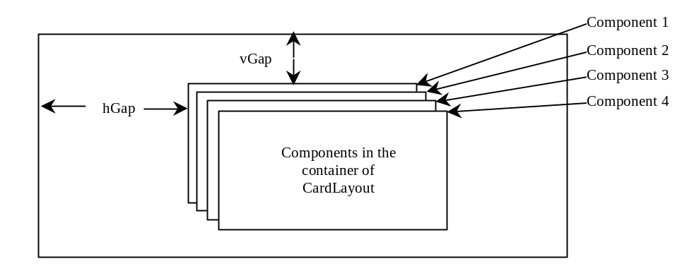

Figure 37.2
The CardLayout places components in the container as a stack of cards.
CardLayout defines a set of methods that allow an application to flip through the cards sequentially or to display a specified card directly, as shown in Figure 37.3.

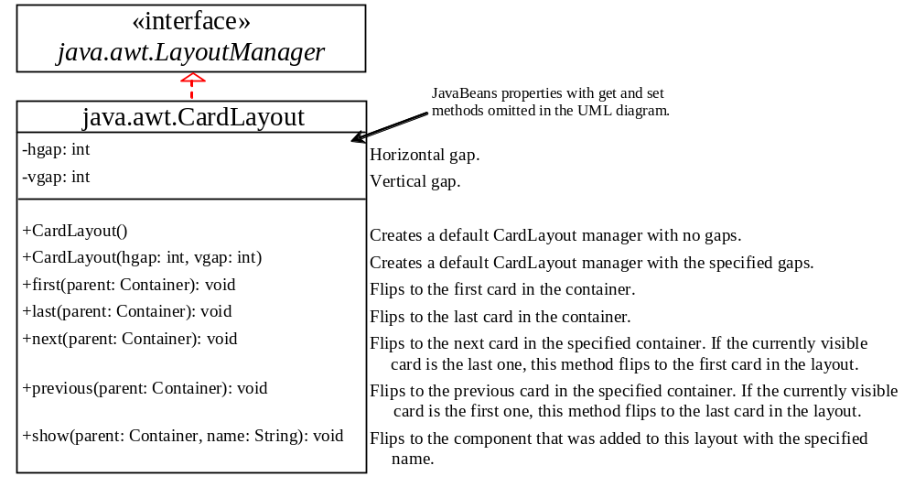

Figure 37.3
CardLayout contains the methods to flip the card.
To add a component into a container, use the add(Component c, String name) method defined in the LayoutManager interface. The String parameter, name, gives an explicit identity to the component in the container.

Listing 37.1 gives a program that creates two panels in a frame. The first panel uses CardLayout to hold six labels for displaying images. The second panel uses FlowLayout to group four buttons named First, Next, Previous, and Last, and a combo box labeled Image, as shown in Figure 37.4.

These buttons control which image will be shown in the CardLayout panel. When the user clicks the button named First, for example, the first image in the CardLayout panel appears. The combo box enables the user to directly select an image.

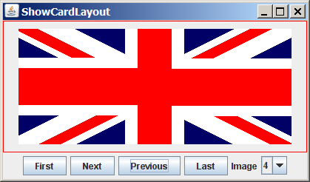

Figure 37.4
The program shows images in a panel of CardLayout.

Listing 37.1 ShowCardLayout.java
<margin note line 6: card layout>
<margin note line 13: create UI>
<margin note line 41: register listener>
<margin note line 45: first component>
<margin note line 47: register listener>
<margin note line 52: next component>
<margin note line 55: register listener>
<margin note line 59: previous component>
<margin note line 62: register listener>
<margin note line 66: last component>
<margin note line 69: register listener>
<margin note line 77: main method omitted>

1 import java.awt.*;
2 import java.awt.event.*;
3 import javax.swing.*;
4
5 public class ShowCardLayout extends JApplet {
6 private CardLayout cardLayout = new CardLayout(20, 10);
7 private JPanel cardPanel = new JPanel(cardLayout);
8 private JButton jbtFirst, jbtNext, jbtPrevious, jbtLast;
9 private JComboBox jcboImage;
10 private final int NUM_OF_FLAGS = 6;
11
12 public ShowCardLayout() {
13 cardPanel.setBorder(
14 new javax.swing.border.LineBorder(Color.red));
15
16 // Add 9 labels for displaying images into cardPanel
17 for (int i = 1; i <= NUM_OF_FLAGS; i++) {
18 JLabel label =
19 new JLabel(new ImageIcon("image/flag" + i + ".gif"));
20 cardPanel.add(label, String.valueOf(i));
21 }
22
23 // Panel p to hold buttons and a combo box
24 JPanel p = new JPanel();
25 p.add(jbtFirst = new JButton("First"));
26 p.add(jbtNext = new JButton("Next"));
27 p.add(jbtPrevious= new JButton("Previous"));
28 p.add(jbtLast = new JButton("Last"));
29 p.add(new JLabel("Image"));
30 p.add(jcboImage = new JComboBox());
31
32 // Initialize combo box items
33 for (int i = 1; i <= NUM_OF_FLAGS; i++)
34 jcboImage.addItem(String.valueOf(i));
35
36 // Place panels in the frame
37 add(cardPanel, BorderLayout.CENTER);
38 add(p, BorderLayout.SOUTH);
39
40 // Register listeners with the source objects
41 jbtFirst.addActionListener(new ActionListener() {
42 @Override
43 public void actionPerformed(ActionEvent e) {
44 // Show the first component in cardPanel
45 cardLayout.first(cardPanel);
46 }
47 });
48 jbtNext.addActionListener(new ActionListener() {
49 @Override
50 public void actionPerformed(ActionEvent e) {
51 // Show the first component in cardPanel
52 cardLayout.next(cardPanel);
53 }
54 });
55 jbtPrevious.addActionListener(new ActionListener() {
56 @Override
57 public void actionPerformed(ActionEvent e) {
58 // Show the first component in cardPanel
59 cardLayout.previous(cardPanel);
60 }
61 });
62 jbtLast.addActionListener(new ActionListener() {
63 @Override
64 public void actionPerformed(ActionEvent e) {
65 // Show the first component in cardPanel
66 cardLayout.last(cardPanel);
67 }
68 });
69 jcboImage.addItemListener(new ItemListener() {
70 @Override
71 public void itemStateChanged(ItemEvent e) {
72 // Show the component at specified index
73 cardLayout.show(cardPanel, (String)e.getItem());
74 }
75 });
76 }
77 }

An instance of CardLayout is created in line 6, and a panel of CardLayout is created in line 7. You have already used such statements as setLayout(new FlowLayout()) to create an anonymous layout object and set the layout for a container, instead of creating a separate instance of the layout manager, as in this program. The cardLayout object, however, is useful later in the program to show components in cardPanel. You have to use cardLayout.first(cardPanel) (line 45), for example, to view the first component in cardPanel.

The statement in lines 18–20 adds the image label with the identity String.valueOf(i). Later, when the user selects an image with number i, the identity String.valueOf(i) is used in the cardLayout.show() method (line 73) to view the image with the specified identity.

37.3.2 BoxLayout
javax.swing.BoxLayout is a Swing layout manager that arranges components in a row or a column. To create a BoxLayout, use the following constructor:

public BoxlayLayout(Container target, int axis)

This constructor is different from other layout constructors. It creates a layout manager that is dedicated to the given target container. The axis parameter is BoxLayout.X_AXIS or BoxLayout.Y_AXIS, which specifies whether the components are laid out horizontally or vertically. For example, the following code creates a horizontal BoxLayout for panel p1:

JPanel p1 = new JPanel();

BoxLayout boxLayout = new BoxLayout(p1, BoxLayout.X_AXIS);
p1.setLayout(boxLayout);

You still need to invoke the setLayout method on p1 to set the layout manager.

You can use BoxLayout in any container, but it is simpler to use the Box class, which is a container of BoxLayout. To create a Box container, use one of the following two static methods:

Box box1 = Box.createHorizontalBox();

Box box2 = Box.createVerticalBox();
The former creates a box that contains components horizontally, the latter a box that contains components vertically.
You can add components to a box in the same way that you add them to the containers of FlowLayout or GridLayout using the add method, as follows:

box1.add(new JButton("A Button"));

You can remove components from a box in the same way that you drop components to a container. The components are laid left to right in a horizontal box, and top to bottom in a vertical box.
BoxLayout is similar to GridLayout but has many unique features.
First, BoxLayout respects a component's preferred size, maximum size, and minimum size. If the total preferred size of all the components in the box is less than the box size, then the components are expanded up to their maximum size. If the total preferred size of all the components in the box is greater than the box size, then the components are shrunk down to their minimum size. If the components do not fit at their minimum width, some of them will not be shown. In the GridLayout, the container is divided into cells of equal size, and the components are fit in regardless of their preferred maximum or minimum size.

Second, unlike other layout managers, BoxLayout considers the component's alignmentX or alignmentY property. The alignmentX property is used to place the component in a vertical box layout, and the alignmentY property is used to place it in a horizontal box layout.
Third, BoxLayout does not have gaps between the components, but you can use fillers to separate components. A filler is an invisible component. There are three kinds of fillers: struts, rigid areas, and glues.
<side remark: strut>
A strut simply adds some space between components. The static method createHorizontalStrut(int) in the Box class is used to create a horizontal strut, and the static method createVerticalStrut(int) to create a vertical strut. For example, the code shown below adds a vertical strut of 8 pixels between two buttons in a vertical box.

box2.add(new JButton("Button 1"));
box2.add(Box.createVerticalStrut(8));
box2.add(new JButton("Button 2"));
<side remark: rigid area>
A rigid area is a two-dimensional space that can be created using the static method createRigidArea(dimension) in the Box class. For example, the next code adds a rigid area 10 pixels wide and 20 pixels high into a box.

box2.add(Box.createRigidArea(new Dimension(10, 20));

<side remark: glue>
A glue separates components as much as possible. For example, by adding a glue between two components in a horizontal box, you place one component at the left end and the other at the right end. A glue can be created using the Box.createGlue() method.

Listing 37.2 shows an example that creates a horizontal box and a vertical box. The horizontal box holds two buttons with print and save icons. The vertical box holds four buttons for selecting flags. When a button in the vertical box is clicked, a corresponding flag icon is displayed in the label centered in the applet, as shown in Figure 37.5.
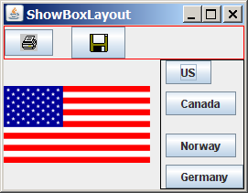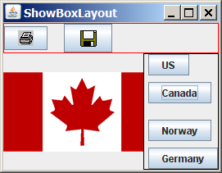

Figure 37.5
The components are placed in the containers of BoxLayout.

Listing 37.2 ShowBoxLayout.java
<margin note line 6: UI components>
<margin note line 7: BoxLayout container>
<margin note line 8: BoxLayout container>
<margin note line 14: create icons>
<margin note line 28: buttons>
<margin note line 34: create UI>
<margin note line 35: add to box>
<margin note line 79: main method omitted>

1 import java.awt.*;
2 import java.awt.event.*;
3 import javax.swing.*;
4
5 public class ShowBoxLayout extends JApplet {
6 // Create two box containers
7 private Box box1 = Box.createHorizontalBox();
8 private Box box2 = Box.createVerticalBox();
9
10 // Create a label to display flags
11 private JLabel jlblFlag = new JLabel();
12
13 // Create image icons for flags
14 private ImageIcon imageIconUS =
15 new ImageIcon(getClass().getResource("/image/us.gif"));
16 private ImageIcon imageIconCanada =
17 new ImageIcon(getClass().getResource("/image/ca.gif"));
18 private ImageIcon imageIconNorway =
19 new ImageIcon(getClass().getResource("/image/norway.gif"));
20 private ImageIcon imageIconGermany =
21 new ImageIcon(getClass().getResource("/image/germany.gif"));
22 private ImageIcon imageIconPrint =
23 new ImageIcon(getClass().getResource("/image/print.gif"));
24 private ImageIcon imageIconSave =
25 new ImageIcon(getClass().getResource("/image/save.gif"));
26
27 // Create buttons to select images
28 private JButton jbtUS = new JButton("US");
29 private JButton jbtCanada = new JButton("Canada");
30 private JButton jbtNorway = new JButton("Norway");
31 private JButton jbtGermany = new JButton("Germany");
32
33 public ShowBoxLayout() {
34 box1.add(new JButton(imageIconPrint));
35 box1.add(Box.createHorizontalStrut(20));
36 box1.add(new JButton(imageIconSave));
37
38 box2.add(jbtUS);
39 box2.add(Box.createVerticalStrut(8));
40 box2.add(jbtCanada);
41 box2.add(Box.createGlue());
42 box2.add(jbtNorway);
43 box2.add(Box.createRigidArea(new Dimension(10, 8)));
44 box2.add(jbtGermany);
45
46 box1.setBorder(new javax.swing.border.LineBorder(Color.red));
47 box2.setBorder(new javax.swing.border.LineBorder(Color.black));
48
49 add(box1, BorderLayout.NORTH);
50 add(box2, BorderLayout.EAST);
51 add(jlblFlag, BorderLayout.CENTER);
52
53 // Register listeners
54 jbtUS.addActionListener(new ActionListener() {
55 @Override
56 public void actionPerformed(ActionEvent e) {
57 jlblFlag.setIcon(imageIconUS);
58 }
59 });
60 jbtCanada.addActionListener(new ActionListener() {
61 @Override
62 public void actionPerformed(ActionEvent e) {
63 jlblFlag.setIcon(imageIconCanada);
64 }
65 });
66 jbtNorway.addActionListener(new ActionListener() {
67 @Override
68 public void actionPerformed(ActionEvent e) {
69 jlblFlag.setIcon(imageIconNorway);
70 }
71 });
72 jbtGermany.addActionListener(new ActionListener() {
73 @Override
74 public void actionPerformed(ActionEvent e) {
75 jlblFlag.setIcon(imageIconGermany);
76 }
77 });
78 }
79 }

Two containers of the Box class are created in lines 7-8 using the convenient static methods createHorizontalBox() and createVerticalBox(). The box containers always use the BoxLayout manager. You cannot reset the layout manager for the box containers.

The image icons are created from image files (lines 14-25) through resource URL, introduced in Section 18.10, “Locating Resource Using the URL Class.”

Two buttons with print and save icons are added into the horizontal box (line 34-36). A horizontal strut with size 20 is added between these two buttons (line 35).

Four buttons with texts US, Canada, Norway, and Germany are added into the vertical box (lines 38-44). A horizontal strut with size 8 is added to separate the US button and the Canada button (line 39). A rigid area is inserted between the Norway button and the Germany button (line 43). A glue is inserted to separate the Canada button and the Norway button as far as possible in the vertical box.

The strut, rigid area, and glue are instances of Component, so they can be added to the box container. In theory, you can add them to a container other than the box container. But they may be ignored and have no effect in other containers.

37.3.3 Using Null Layout Manager
If you have used a Windows-based visual form design tool like Visual Basic, you know that it is easier to create user interfaces with Visual Basic than in Java. This is mainly because in Visual Basic the components are placed in absolute positions and sizes, whereas in Java they are placed in containers using a variety of layout managers. Absolute positions and sizes are fine if the application is developed and deployed on the same platform, but what looks fine on a development system may not look right on a deployment system. To solve this problem, Java provides a set of layout managers that place components in containers in a way that is independent of fonts, screen resolutions, and platform differences.

For convenience, Java also supports an absolute layout, called null layout manager, which enables you to place components at fixed locations. In this case, the component must be placed using the component's instance method setBounds() (defined in java.awt.Component), as follows:

public void setBounds(int x, int y, int width, int height);
This sets the location and size for the component, as in the next example:

JButton jbt = new JButton("Help");
jbt.setBounds(10, 10, 40, 20);

The upper-left corner of the Help button is placed at (10, 10); the button width is 40, and the height is 20.
Here are the steps of adding a button to a container with a null layout manager:

1. Use this statement to specify a null layout manager:
<margin note: set null layout>
container.setLayout(null);

2. Add the component to the container:

JButton jbt = new JButton("Help");
container.add(jbt);

3. Specify the location where the component is to be placed, using the setBounds method:
<margin note: setBounds>
jbt.setBounds(10, 10, 40, 20);

Listing 37.3 gives a program that places three buttons, as shown in Figure 37.6a.
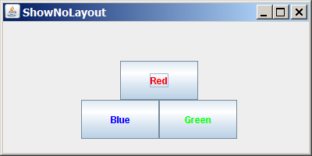 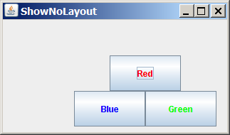
(a) (b)

Figure 37.6
(a) The components are placed in the frame using a null layout manager. (b) With a null layout manager, the size and positions of the components are fixed.

Listing 37.3 ShowNoLayout.java
<margin note line 5: UI components>
<margin note line 11: create UI>
<margin note line 28: main method omitted>

1 import java.awt.*;
2 import javax.swing.*;
3
4 public class ShowNoLayout extends JApplet {
5 private JButton jbtRed = new JButton("Red" );
6 private JButton jbtBlue = new JButton("Blue" );
7 private JButton jbtGreen = new JButton("Green" );
8
9 public ShowNoLayout() {
10 // Set foreground color for the buttons
11 jbtRed.setForeground(Color.RED);
12 jbtBlue.setForeground(Color.BLUE);
13 jbtGreen.setForeground(Color.GREEN);
14
15 // Specify no layout manager
16 setLayout(null);
17
18 // Add components to container
19 add(jbtRed);
20 add(jbtBlue);
21 add(jbtGreen);
22
23 // Put components in the right place
24 jbtRed.setBounds(150, 50, 100, 50);
25 jbtBlue.setBounds(100, 100, 100, 50);
26 jbtGreen.setBounds(200, 100, 100, 50);
27 }
28 }

If you run this program on Windows with 1024 × 768 resolution, the layout size is just right. When the program is run on Windows with a higher resolution, the components appear very small and clump together. When it is run on Windows with a lower resolution, they cannot be shown in their entirety.

If you resize the window, you will see that the location and the size of the components are not changed, as shown in Figure 37.6b.

TIP
Do not use the null-layout-manager to develop platform-independent applications.

37.4 Creating Custom Layout Managers
In addition to the layout managers provided in Java, you can create your own. To do so, you need to understand how a layout manager lays out components. A container's setLayout method specifies a layout manager for the container. The layout manager is responsible for laying out the components and displaying them in a desired location with an appropriate size. Every layout manager must directly or indirectly implement the LayoutManager interface. For instance, FlowLayout directly implements LayoutManager, and BorderLayout implements LayoutManager2, a subclass of LayoutManager. The LayoutManager interface provides the following methods for laying out components in a container:

- public void addLayoutComponent(String name, Component comp)
Adds the specified component with the specified name to the container.
- public void layoutContainer(Container parent)
Lays out the components in the specified container. In this method, you should provide concrete instructions that specify where the components are to be placed.
- public Dimension minimumLayoutSize(Container parent)
Calculates the minimum size dimensions for the specified panel, given the components in the specified parent container.
- public Dimension preferredLayoutSize(Container parent)
Calculates the preferred size dimensions for the specified panel, given the components in the specified parent container.
- public void removeLayoutComponent(Component comp)
Removes the specified component from the layout.
These methods in LayoutManager are invoked by the methods in the java.awt.Container class through the layout manager in the container. Container contains a property named layout (an instance of LayoutManager) and the methods for adding and removing components from the container. There are five overloading add methods defined in Container for adding components with various options. The remove method removes a component from the container. The add method invokes addImpl, which then invokes the addLayoutComponent method defined in the LayoutManager interface. The layoutContainer method in the LayoutManager interface is indirectly invoked by the validate() method through several calls. The remove method invokes removeLayoutComponent in LayoutManager. The validate method is invoked to refresh the container after the components it contains have been added to or modified. The relationship of Container and LayoutManager is shown in Figure 37.7.

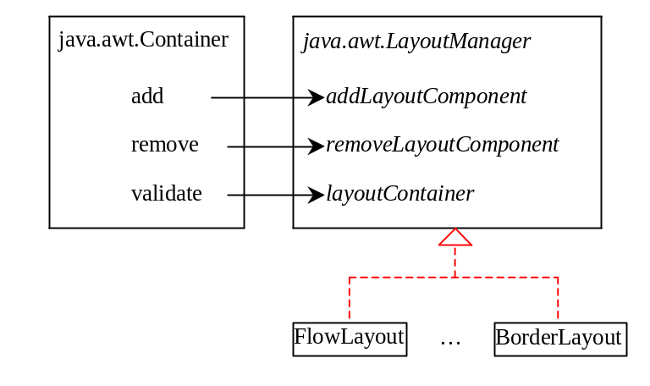

Figure 37.7
The add, remove, and validate methods in Container invoke the methods defined in the LayoutManager interface.
Let us define a custom layout manager named DiagonalLayout that places the components in a diagonal. To test DiagonalLayout, the example creates an applet with radio buttons named “FlowLayout,” “GridLayout,” and “DiagonalLayout,” as shown in Figure 37.8. You can dynamically select one of these three layouts in the panel.

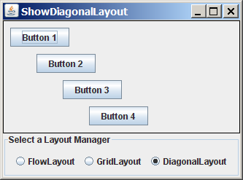

Figure 37.8
The DiagonalLayout manager places the components in a diagonal in the container.
DiagonalLayout is similar to FlowLayout. DiagonalLayout arranges components along a diagonal using each component's natural preferredSize. It contains three constraints, gap, lastFill, and majorDiagonal, as shown in Figure 37.9. The source code for DiagonalLayout is given in Listing 37.4.

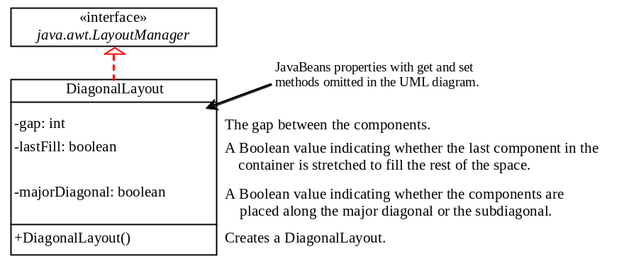

Figure 37.9
The DiagonalLayout manager has three properties with the supporting accessor and mutator methods.

Listing 37.4 DiagonalLayout.java
<margin note line 6: properties>
<margin note line 34: layout container>

1 import java.awt.*;
2
3 public class DiagonalLayout implements LayoutManager,
4 java.io.Serializable {
5 /** Vertical gap between the components */
6 private int gap = 10;
7
8 /** True if components are placed along the major diagonal */
9 private boolean majorDiagonal = true;
10
11 /*True if the last component is stretched to fill the space */
12 private boolean lastFill = false;
13
14 /** Constructor */
15 public DiagonalLayout() {
16 }
17
18 public void addLayoutComponent(String name, Component comp) {
19 // No need to implement it for DiaganolLayout
20 }
21
22 public void removeLayoutComponent(Component comp) {
23 // No need to implement it for DiaganolLayout
24 }
25
26 public Dimension preferredLayoutSize(Container parent) {
27 return minimumLayoutSize(parent);
28 }
29
30 public Dimension minimumLayoutSize(Container parent) {
31 return new Dimension(0, 0);
32 }
33
34 public void layoutContainer(Container parent) {
35 int numberOfComponents = parent.getComponentCount();
36
37 Insets insets = parent.getInsets();
38 int w = parent.getSize().width - insets.left - insets.right;
39 int h = parent.getSize().height - insets.bottom - insets.top;
40
41 if (majorDiagonal) {
42 int x = 10, y = 10;
43
44 for (int j = 0; j < numberOfComponents; j++) {
45 Component c = parent.getComponent(j);
46 Dimension d = c.getPreferredSize();
47
48 if (c.isVisible())
49 if (lastFill && (j == numberOfComponents - 1))
50 c.setBounds(x, y, w - x, h - y);
51 else
52 c.setBounds(x, y, d.width, d.height);
53 x += d.height + gap;
54 y += d.height + gap;
55 }
56 }
57 else { // It is subdiagonal
58 int x = w - 10, y = 10;
59
60 for (int j = 0; j < numberOfComponents; j++) {
61 Component c = parent.getComponent(j);
62 Dimension d = c.getPreferredSize();
63
64 if (c.isVisible())
65 if (lastFill & (j == numberOfComponents - 1))
66 c.setBounds(0, y, x, h - y);
67 else
68 c.setBounds(x - d.width, y, d.width, d.height);
69
70 x -= (d.height + gap);
71 y += d.height + gap;
72 }
73 }
74 }
75
76 public int getGap() {
77 return gap;
78 }
79
80 public void setGap(int gap) {
81 this.gap = gap;
82 }
83
84 public void setMajorDiagonal(boolean newMajorDiagonal) {
85 majorDiagonal = newMajorDiagonal;
86 }
87
88 public boolean isMajorDiagonal() {
89 return majorDiagonal;
90 }
91
92 public void setLastFill(boolean newLastFill) {
93 lastFill = newLastFill;
94 }
95
96 public boolean isLastFill() {
97 return lastFill;
98 }
99 }

The DiagonalLayout class implements the LayoutManager and Serializable interfaces (lines 3-4). The reason to implement Serializable is to make it a JavaBeans component.

The Insets class describes the size of the borders of a container. It contains the variables left, right, bottom, and top, which correspond to the measurements for the left border, right border, top border, and bottom border (lines 37-39).

The Dimension class used in DiagonalLayout encapsulates the width and height of a component in a single object. The class is associated with certain properties of components. Several methods defined by the Component class and the LayoutManager interface return a Dimension object.

Listing 37.5 gives a test program that uses DiagonalLayout.

Listing 37.5 ShowDiagonalLayout.java
<margin note line 9: diagonal layout>
<margin note line 27: create UI>
<margin note line 48: register listener>
<margin note line 55: register listener>
<margin note line 62: register listener>
<margin note line 70: main method omitted>

1 import javax.swing.*;
2 import javax.swing.border.*;
3 import java.awt.*;
4 import java.awt.event.*;
5
6 public class ShowDiagonalLayout extends JApplet {
7 private FlowLayout flowLayout = new FlowLayout();
8 private GridLayout gridLayout = new GridLayout(2, 2);
9 private DiagonalLayout diagonalLayout = new DiagonalLayout();
10
11 private JButton jbt1 = new JButton("Button 1");
12 private JButton jbt2 = new JButton("Button 2");
13 private JButton jbt3 = new JButton("Button 3");
14 private JButton jbt4 = new JButton("Button 4");
15
16 private JRadioButton jrbFlowLayout =
17 new JRadioButton("FlowLayout");
18 private JRadioButton jrbGridLayout =
19 new JRadioButton("GridLayout");
20 private JRadioButton jrbDiagonalLayout =
21 new JRadioButton("DiagonalLayout", true);
22
23 private JPanel jPanel2 = new JPanel();
24
25 public ShowDiagonalLayout() {
26 // Set default layout in jPanel2
27 jPanel2.setLayout(diagonalLayout);
28 jPanel2.add(jbt1);
29 jPanel2.add(jbt2);
30 jPanel2.add(jbt3);
31 jPanel2.add(jbt4);
32 jPanel2.setBorder(new LineBorder(Color.black));
33
34 JPanel jPanel1 = new JPanel();
35 jPanel1.setBorder(new TitledBorder("Select a Layout Manager"));
36 jPanel1.add(jrbFlowLayout);
37 jPanel1.add(jrbGridLayout);
38 jPanel1.add(jrbDiagonalLayout);
39
40 ButtonGroup buttonGroup1 = new ButtonGroup();
41 buttonGroup1.add(jrbFlowLayout);
42 buttonGroup1.add(jrbGridLayout);
43 buttonGroup1.add(jrbDiagonalLayout);
44
45 add(jPanel1, BorderLayout.SOUTH);
46 add(jPanel2, BorderLayout.CENTER);
47
48 jrbFlowLayout.addActionListener(new ActionListener() {
49 @Override
50 public void actionPerformed(ActionEvent e) {
51 jPanel2.setLayout(flowLayout);
52 jPanel2.validate();
53 }
54 });
55 jrbGridLayout.addActionListener(new ActionListener() {
56 @Override
57 public void actionPerformed(ActionEvent e) {
58 jPanel2.setLayout(gridLayout);
59 jPanel2.validate();
60 }
61 });
62 jrbDiagonalLayout.addActionListener(new ActionListener() {
63 @Override
64 public void actionPerformed(ActionEvent e) {
65 jPanel2.setLayout(diagonalLayout);
66 jPanel2.validate();
67 }
68 });
69 }
70 }

The TestDiagonalLayout class enables you to dynamically set the layout in jPanel2. When you select a new layout, the layout manager is set in jPanel2, and the revalidate() method is invoked (lines 52, 59, 66), which in turn invokes the layoutContainer method in the LayoutManager interface to display the components in the container.

37.5 JScrollPane
Often you need to use a scroll bar to scroll the contents of an object that does not fit completely into the viewing area. JScrollBar and JSlider can be used for this purpose, but you have to manually write the code to implement scrolling with them. JScrollPane is a component that supports automatic scrolling without coding. It was used to scroll the text area in Listing 17.3, TextAreaDemo.java, and to scroll a list in Listing 17.5, ListDemo.java. In fact, it can be used to scroll any subclass of JComponent.

A JScrollPane can be viewed as a specialized container with a view port for displaying the contained component. In addition to horizontal and vertical scroll bars, a JScrollPane can have a column header, a row header, and corners, as shown in Figure 37.10.

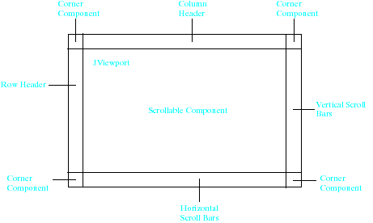

Figure 37.10
A JScrollPane has a view port, optional horizontal and vertical bars, optional column and row headers, and optional corners.
<margin note: view port>
The view port is an instance of JViewport through which a scrollable component is displayed. When you add a component to a scroll pane, you are actually placing it in the scroll pane's view port. Figure 37.11 shows the frequently used properties, constructors, and methods in JScrollPane.

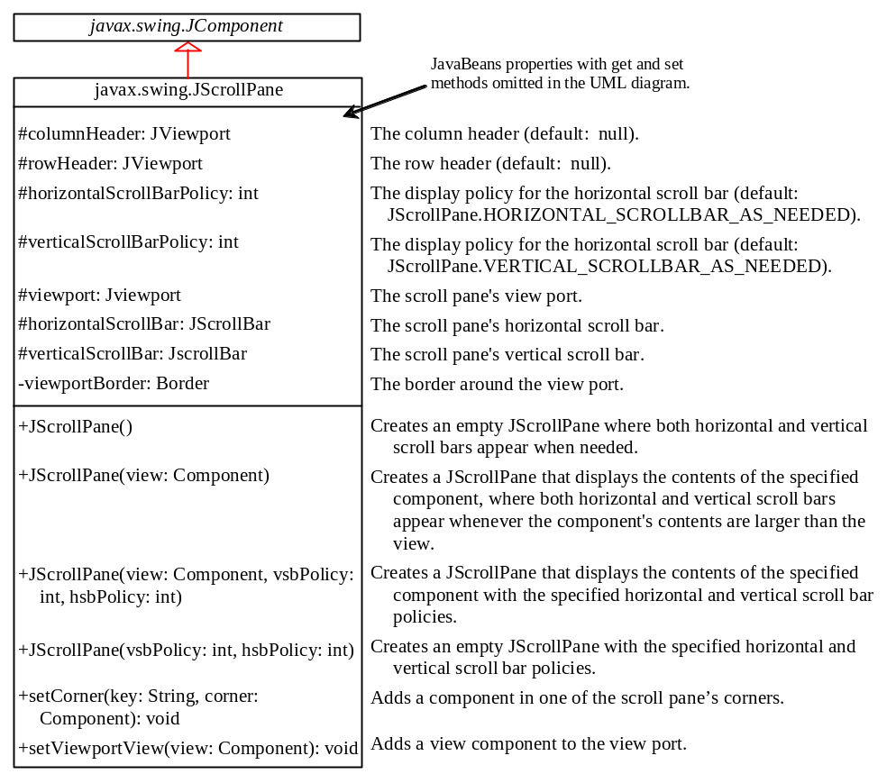

Figure 37.11
JScrollPane provides methods for displaying and manipulating the components in a scroll pane.
The constructor always creates a view port regardless of whether the viewing component is specified. Normally, you have the component and you want to place it in a scroll pane. A convenient way to create a scroll pane for a component is to use the JScrollPane(component) constructor.

The vsbPolicy parameter can be one of the following three values:

JScrollPane.VERTICAL_SCROLLBAR_AS_NEEDED

JScrollPane.VERTICAL_SCROLLBAR_NEVER

JScrollPane.VERTICAL_SCROLLBAR_ALWAYS
The hsbPolicy parameter can be one of the following three values:

JScrollPane.HORIZONTAL_SCROLLBAR_AS_NEEDED

JScrollPane.HORIZONTAL_SCROLLBAR_NEVER

JScrollPane.HORIZONTAL_SCROLLBAR_ALWAYS
To set a corner component, you can use the setCorner(String key, Component corner) method. The legal values for the key are:

JScrollPane.LOWER_LEFT_CORNER

JScrollPane.LOWER_RIGHT_CORNER

JScrollPane.UPPER_LEFT_CORNER

JScrollPane.UPPER_RIGHT_CORNER
Listing 37.6 shows an example that displays a map in a label and places the label in a scroll pane so that a large map can be scrolled. The program lets you choose a map from a combo box and display it in the scroll pane, as shown in Figure 37.12.

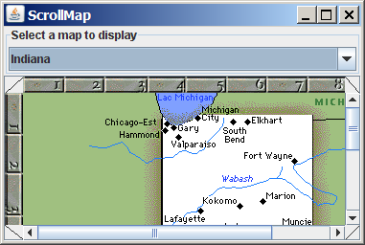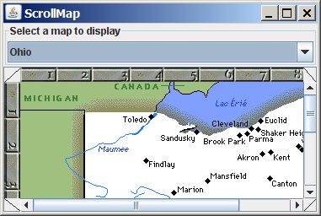

Figure 37.12
The scroll pane can be used to scroll contents automatically.

Listing 37.6 ScrollMap.java
<margin note line 8: labels>
<margin note line 17: create UI>
<margin note line 28: scroll pane>
<margin note line 46: register listener>
<margin note line 88: main method omitted >

1 import java.awt.*;
2 import java.awt.event.*;
3 import javax.swing.*;
4 import javax.swing.border.*;
5
6 public class ScrollMap extends JApplet {
7 // Create images in labels
8 private JLabel lblIndianaMap = new JLabel(
9 new ImageIcon(getClass().getResource("image/indianaMap.gif")));
10 private JLabel lblOhioMap = new JLabel(
11 new ImageIcon(getClass().getResource("/image/ohioMap.gif")));
12
13 // Create a scroll pane to scroll map in the labels
14 private JScrollPane jspMap = new JScrollPane(lblIndianaMap);
15
16 public ScrollMap() {
17 // Create a combo box for selecting maps
18 JComboBox jcboMap = new JComboBox(new String[]{"Indiana",
19 "Ohio"});
20
21 // Panel p to hold combo box
22 JPanel p = new JPanel();
23 p.setLayout(new BorderLayout());
24 p.add(jcboMap);
25 p.setBorder(new TitledBorder("Select a map to display"));
26
27 // Set row header, column header and corner header
28 jspMap.setColumnHeaderView(new JLabel(new ImageIcon(getClass().
29 getResource("/image/horizontalRuler.gif"))));
30 jspMap.setRowHeaderView(new JLabel(new ImageIcon(getClass().
31 getResource("/image/verticalRuler.gif"))));
32 jspMap.setCorner(JScrollPane.UPPER_LEFT_CORNER,
33 new CornerPanel(JScrollPane.UPPER_LEFT_CORNER));
34 jspMap.setCorner(ScrollPaneConstants.UPPER_RIGHT_CORNER,
35 new CornerPanel(JScrollPane.UPPER_RIGHT_CORNER));
36 jspMap.setCorner(JScrollPane.LOWER_RIGHT_CORNER,
37 new CornerPanel(JScrollPane.LOWER_RIGHT_CORNER));
38 jspMap.setCorner(JScrollPane.LOWER_LEFT_CORNER,
39 new CornerPanel(JScrollPane.LOWER_LEFT_CORNER));
40
41 // Add the scroll pane and combo box panel to the frame
42 add(jspMap, BorderLayout.CENTER);
43 add(p, BorderLayout.NORTH);
44
45 // Register listener
46 jcboMap.addItemListener(new ItemListener() {
47 /** Show the selected map */
48 public void itemStateChanged(ItemEvent e) {
49 String selectedItem = (String)e.getItem();
50 if (selectedItem.equals("Indiana")) {
51 // Set a new view in the view port
52 jspMap.setViewportView(lblIndianaMap);
53 }
54 else if (selectedItem.equals("Ohio")) {
55 // Set a new view in the view port
56 jspMap.setViewportView(lblOhioMap);
57 }
58
59 // Revalidate the scroll pane
60 jspMap.revalidate();
61 }
62 });
63 }
64
65 // A panel displaying a line used for scroll pane corner
66 class CornerPanel extends JPanel {
67 // Line location
68 private String location;
69
70 public CornerPanel(String location) {
71 this.location = location;
72 }
73
74 @Override /** Draw a line depending on the location */
75 protected void paintComponent(Graphics g) {
76 super.paintComponents(g);
77
78 if (location == "UPPER_LEFT_CORNER")
79 g.drawLine(0, getHeight(), getWidth(), 0);
80 else if (location == "UPPER_RIGHT_CORNER")
81 g.drawLine(0, 0, getWidth(), getHeight());
82 else if (location == "LOWER_RIGHT_CORNER")
83 g.drawLine(0, getHeight(), getWidth(), 0);
84 else if (location == "LOWER_LEFT_CORNER")
85 g.drawLine(0, 0, getWidth(), getHeight());
86 }
87 }
88 }

The program creates a scroll pane to view image maps. The images are created from image files and displayed in labels (lines 8-11). To view an image, the label that contains the image is placed in the scroll pane's view port (line 14).
The scroll pane has a main view, a header view, a column view, and four corner views. Each view is a subclass of Component. Since ImageIcon is not a subclass of Component, it cannot be directly used as a view in the scroll pane. Instead the program places an ImageIcon to a label and uses the label as a view.
The CornerPanel (lines 66-87) is a subclass of JPanel that is used to display a line. How the line is drawn depends on the location of the corner. The location is a string passed in as a parameter in the CornerPanel's constructor.
Whenever a new map is selected, the label for displaying the map image is set to the scroll pane's view port. The revalidate() method (line 60) must be invoked to cause the new image to be displayed. The revalidate() method causes a container to lay out its subcomponents again after the components it contains have been added to or modified.

37.6 JTabbedPane
JTabbedPane is a useful Swing container that provides a set of mutually exclusive tabs for accessing multiple components, as shown in Figure 37.13.

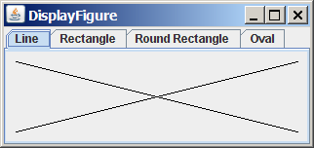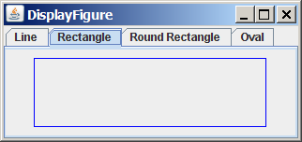

Figure 37.13
JTabbedPane displays components through the tabs.
Usually you place the panels inside a JTabbedPane and associate a tab with each panel. JTabbedPane is easy to use, because the selection of the panel is handled automatically by clicking the corresponding tab. You can switch between a group of panels by clicking on a tab with a given title and/or icon. Figure 37.14 shows the frequently used properties, constructors, and methods in JTabbedPane.

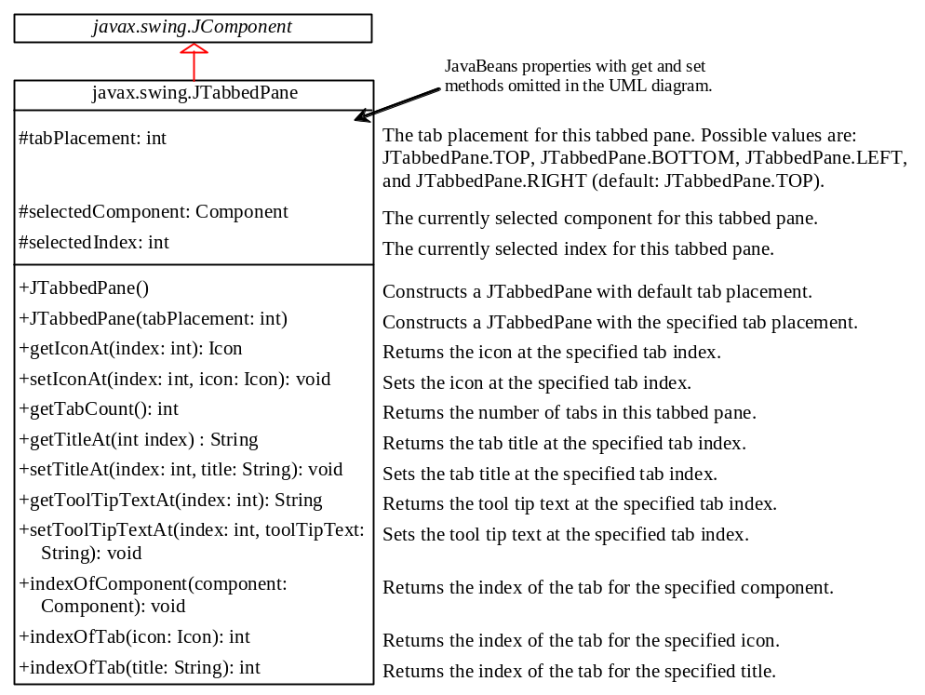

Figure 37.14
JTabbedPane provides methods for displaying and manipulating the components in the tabbed pane.
Listing 37.7 gives an example that uses a tabbed pane with four tabs to display four types of figures: line, rectangle, rounded rectangle, and oval. You can select a figure to display by clicking the corresponding tab, as shown in Figure 37.13. The FigurePanel class for displaying a figure was presented in Listing 15.3, FigurePanel.java. You can use the type property to specify a figure type.

Listing 37.7 DisplayFigure.java
<margin note line 5: tabbed pane>
<margin note line 12: set type>
<margin note line 18: add tabs>
<margin note line 23: set tool tips>
<margin note line 28: main method omitted>

1 import java.awt.*;
2 import javax.swing.*;
3
4 public class DisplayFigure extends JApplet {
5 private JTabbedPane jtpFigures = new JTabbedPane();
6 private FigurePanel squarePanel = new FigurePanel();
7 private FigurePanel rectanglePanel = new FigurePanel();
8 private FigurePanel circlePanel = new FigurePanel();
9 private FigurePanel ovalPanel = new FigurePanel();
10
11 public DisplayFigure() {
12 squarePanel.setType(FigurePanel.LINE);
13 rectanglePanel.setType(FigurePanel.RECTANGLE);
14 circlePanel.setType(FigurePanel.ROUND_RECTANGLE);
15 ovalPanel.setType(FigurePanel.OVAL);
16
17 add(jtpFigures, BorderLayout.CENTER);
18 jtpFigures.add(squarePanel, "Line");
19 jtpFigures.add(rectanglePanel, "Rectangle");
20 jtpFigures.add(circlePanel, "Round Rectangle");
21 jtpFigures.add(ovalPanel, "Oval");
22
23 jtpFigures.setToolTipTextAt(0, "Square");
24 jtpFigures.setToolTipTextAt(1, "Rectangle");
25 jtpFigures.setToolTipTextAt(2, "Circle");
26 jtpFigures.setToolTipTextAt(3, "Oval");
27 }
- }

The program creates a tabbed pane to hold four panels, each of which displays a figure. A panel is associated with a tab. The tabs are titled Line, Rectangle, Rounded Rectangle, and Oval.

By default, the tabs are placed at the top of the tabbed pane. You can select a different placement using the tabPlacement property.

37.7 JSplitPane
JSplitPane is a convenient Swing container that contains two components with a separate bar known as a divider, as shown in Figure 37.15.

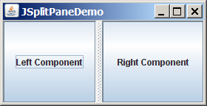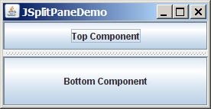
(a) Vertical divider (b) Horizontal divider

Figure 37.15
JSplitPane divides a container into two parts.
The bar can divide the container horizontally or vertically and can be dragged to change the amount of space occupied by each component. Figure 37.16 shows the frequently used properties, constructors, and methods in JSplitPane
.
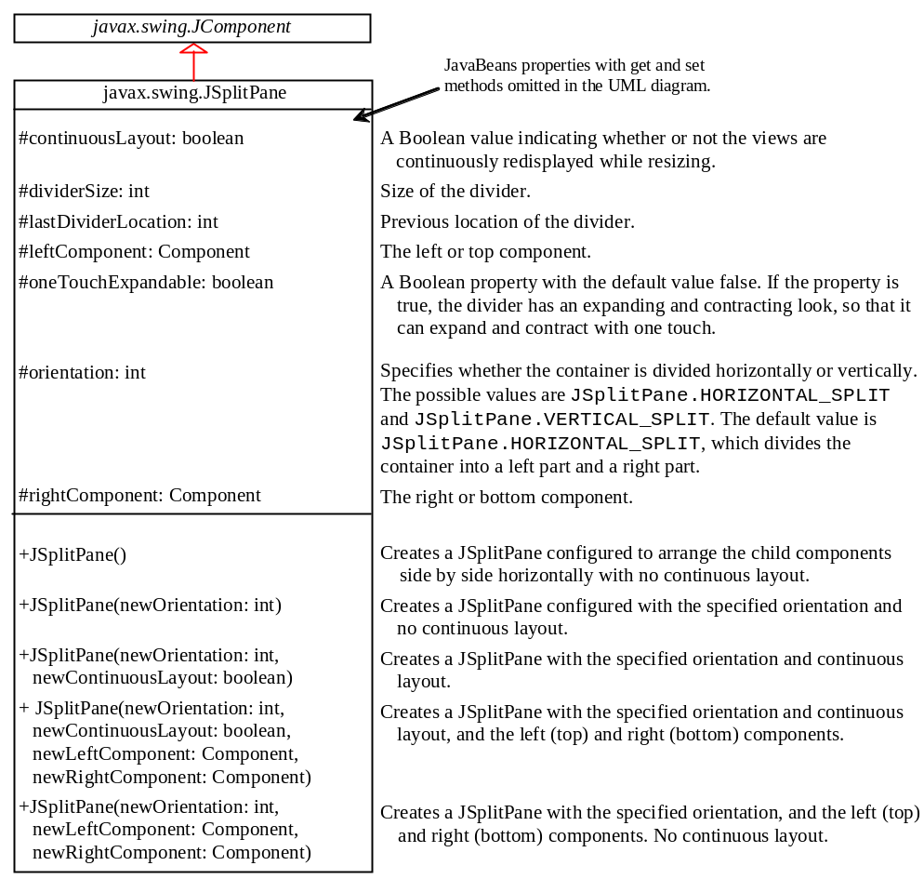

Figure 37.16
JSplitPane provides methods to specify the properties of a split pane and for manipulating the components in a split pane.
Listing 37.8 gives an example that uses radio buttons to let the user select a FlowLayout, GridLayout, or BoxLayout manager dynamically for a panel. The panel contains four buttons, as shown in Figure 37.17. The description of the currently selected layout manager is displayed in a text area. The radio buttons, buttons, and text area are placed in two split panes.

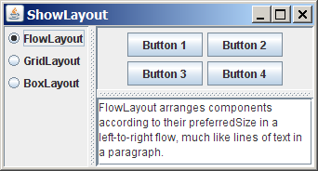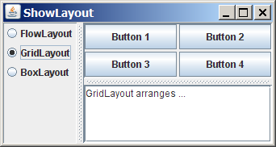

Figure 37.17
You can adjust the component size in the split panes.

Listing 37.8 ShowLayout.java
<margin note line 7: descriptions>
<margin note line 13: radio buttons>
<margin note line 24: layout managers>
<margin note line 54: split pane>
<margin note line 57: split pane>
<margin note line 76: register listener>
<margin note line 81: validate>
<margin note line 84: register listener>
<margin note line 89: validate>
<margin note line 93: main method omitted>

1 import java.awt.*;
2 import java.awt.event.*;
3 import javax.swing.*;
4
5 public class ShowLayout extends JApplet {
6 // Get the url for HTML files
7 private String flowLayoutDesc = "FlowLayout arranges components " +
8 "according to their preferredSize in " +
9 "a left-to-right flow, much like lines of text in a paragraph.";
10 private String gridLayoutDesc = "GridLayout arranges ...";
11 private String boxLayoutDesc = "BoxLayout arranges ...";
12
13 private JRadioButton jrbFlowLayout =
14 new JRadioButton("FlowLayout");
15 private JRadioButton jrbGridLayout =
16 new JRadioButton("GridLayout", true);
17 private JRadioButton jrbBoxLayout =
18 new JRadioButton("BoxLayout");
19
20 private JPanel jpComponents = new JPanel();
21 private JTextArea jtfDescription = new JTextArea();
22
23 // Create layout managers
24 private FlowLayout flowLayout = new FlowLayout();
25 private GridLayout gridLayout = new GridLayout(2, 2, 3, 3);
26 private BoxLayout boxLayout =
27 new BoxLayout(jpComponents, BoxLayout.X_AXIS);
28
29 public ShowLayout() {
30 // Create a box to hold radio buttons
31 Box jpChooseLayout = Box.createVerticalBox();
32 jpChooseLayout.add(jrbFlowLayout);
33 jpChooseLayout.add(jrbGridLayout);
34 jpChooseLayout.add(jrbBoxLayout);
35
36 // Group radio buttons
37 ButtonGroup btg = new ButtonGroup();
38 btg.add(jrbFlowLayout);
39 btg.add(jrbGridLayout);
40 btg.add(jrbBoxLayout);
41
42 // Wrap lines and words
43 jtfDescription.setLineWrap(true);
44 jtfDescription.setWrapStyleWord(true);
45
46 // Add fours buttons to jpComponents
47 jpComponents.add(new JButton("Button 1"));
48 jpComponents.add(new JButton("Button 2"));
49 jpComponents.add(new JButton("Button 3"));
50 jpComponents.add(new JButton("Button 4"));
51
52 // Create two split panes to hold jpChooseLayout, jpComponents,
53 // and jtfDescription
54 JSplitPane jSplitPane2 = new JSplitPane(
55 JSplitPane.VERTICAL_SPLIT, jpComponents,
56 new JScrollPane(jtfDescription));
57 JSplitPane jSplitPane1 = new JSplitPane(
58 JSplitPane.HORIZONTAL_SPLIT, jpChooseLayout, jSplitPane2);
59
60 // Set FlowLayout as default
61 jpComponents.setLayout(flowLayout);
62 jpComponents.revalidate();
63 jtfDescription.setText(flowLayoutDesc);
64
65 add(jSplitPane1, BorderLayout.CENTER);
66
67 // Register listeners
68 jrbFlowLayout.addActionListener(new ActionListener() {
69 @Override
70 public void actionPerformed(ActionEvent e) {
71 jpComponents.setLayout(flowLayout);
72 jtfDescription.setText(flowLayoutDesc);
73 jpComponents.revalidate();
74 }
75 });
76 jrbGridLayout.addActionListener(new ActionListener() {
77 @Override
78 public void actionPerformed(ActionEvent e) {
79 jpComponents.setLayout(gridLayout);
80 jtfDescription.setText(gridLayoutDesc);
81 jpComponents.revalidate();
82 }
83 });
84 jrbBoxLayout.addActionListener(new ActionListener() {
85 @Override
86 public void actionPerformed(ActionEvent e) {
87 jpComponents.setLayout(boxLayout);
88 jtfDescription.setText(boxLayoutDesc);
89 jpComponents.revalidate();
90 }
91 });
92 }
93 }

Split panes can be embedded. Adding a split pane to an existing split pane results in three split panes. The program creates two split panes (lines 54-58) to hold a panel for radio buttons, a panel for buttons, and a scroll pane.

The radio buttons are used to select layout managers. A selected layout manager is used in the panel for laying out the buttons (lines 66-88). The scroll pane contains a JTextArea for displaying the text that describes the selected layout manager (line 56).

37.8 Swing Borders
Swing provides a variety of borders that you can use to decorate components. You learned how to create titled borders and line borders in §12.9, “Common Features of Swing GUI Components.” This section introduces borders in more detail.

A Swing border is defined in the Border interface. Every instance of JComponent can set a border through the border property defined in JComponent. If a border is present, it replaces the inset. The AbstractBorder class implements an empty border with no size. This provides a convenient base class from which other border classes can easily be defined. There are eight concrete border classes, BevelBorder, SoftBevelBorder, CompoundBorder, EmptyBorder, EtchedBorder, LineBorder, MatteBorder, and TitledBorder, as shown in Figure 37.18.

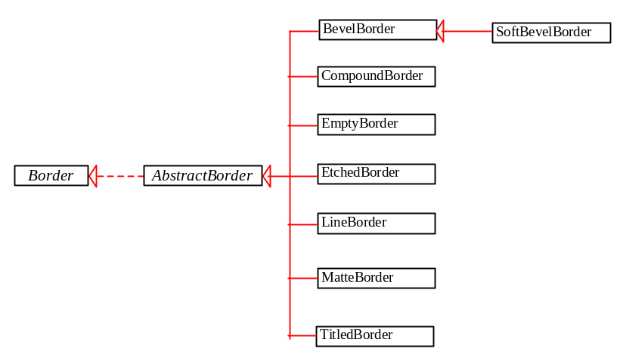

Figure 37.18
The Border interface defines Swing borders.
[BL]BevelBorder is a 3D-look border that can be lowered or raised. BevelBorder has the following constructors, which create a BevelBorder with the specified bevelType (BevelBorder.LOWERED or BevelBorder.RAISED) and colors:
BevelBorder(int bevelType)
BevelBorder(int bevelType, Color highlight, Color shadow)
BevelBorder(int bevelType, Color highlightOuterColor,
Color highlightInnerColor,
Color shadowOuterColor, Color shadowInnerColor)

[BL]SoftBevelBorder is a raised or lowered bevel with softened corners. SoftBevelBorder has the following constructors:
SoftBevelBorder(int bevelType)
SoftBevelBorder(int bevelType, Color highlight, Color shadow)
SoftBevelBorder(int bevelType, Color highlightOuterColor,
Color highlightInnerColor, Color shadowOuterColor,
Color shadowInnerColor)

[BL]EmptyBorder is a border with border space but no drawings. EmptyBorder has the following constructors:
EmptyBorder(Insets borderInsets)
EmptyBorder(int top, int left, int bottom, int right)

[BL]EtchedBorder is an etched border that can be etched-in or etched-out. EtchedBorder has the property etchType with the value LOWERED or RAISED. EtchedBorder has the following constructors:
EtchedBorder() // Default constructor with a lowered border
EtchedBorder(Color highlight, Color shadow)
EtchedBorder(int etchType)
EtchedBorder(int etchType, Color highlight, Color shadow)

[BL]LineBorder draws a line of arbitrary thickness and a single color around the border. LineBorder has the following constructors:
LineBorder(Color color) // Thickness 1
LineBorder(Color color, int thickness)
LineBorder(Color color, int thickness, boolean roundedCorners)

[BL]MatteBorder is a mattelike border padded with the icon images. MatteBorder has the following constructors:
MatteBorder(Icon tileIcon)
MatteBorder(Insets borderInsets, Color matteColor)
MatteBorder(Insets borderInsets, Icon tileIcon)
MatteBorder(int top, int left, int bottom,
int right, Color matteColor)
MatteBorder(int top, int left, int bottom, int right, Icon tileIcon)

[BL]CompoundBorder is used to compose two Border objects into a single border by nesting an inside Border object within the insets of an outside Border object using the following constructor:
CompoundBorder(Border outsideBorder, Border insideBorder)

[BL]TitledBorder is a border with a string title in a specified position. TitledBorder can be composed with other borders. TitledBorder has the following constructors:
TitledBorder(String title)
TitledBorder(Border border) // Empty title on another border
TitledBorder(Border border, String title)
TitledBorder(Border border, String title,
int titleJustification, int titlePosition)
TitledBorder(Border border, String title,
int titleJustification, int titlePosition,
Font titleFont)
TitledBorder(Border border, String title,
int titleJustification, int titlePosition,
Font titleFont, Color titleColor)

For convenience, Java also provides the javax.swing.BorderFactory class, which contains the static methods for creating borders shown in Figure 37.19.

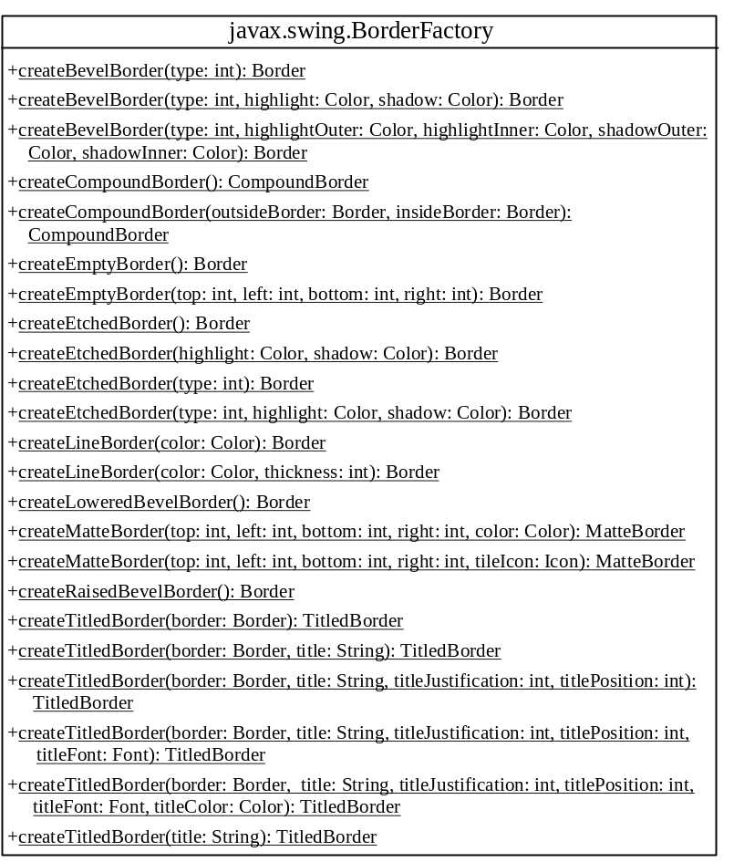

Figure 37.19
BorderFactory contains the static methods for creating various types of borders.
For example, to create an etched border, use the following statement:

Border border = BorderFactory.createEtchedBorder();

NOTE
All the border classes and interfaces are grouped in the package javax.swing.border except javax.swing.BorderFactory.

NOTE
Borders and icons can be shared. Thus you can create a border or icon and use it to set the border or icon property for any GUI component. For example, the following statements set a border b for two panels p1 and p2:
p1.setBorder(b);
p2.setBorder(b);

***End of NOTE

Listing 37.9 gives an example that creates and displays various types of borders. You can select a border with or without a title. For a border without a title, you can choose a border style from Lowered Bevel, Raised Bevel, Etched, Line, Matte, or Empty. For a border with a title, you can specify the title position and justification. You can also embed another border into a titled border. Figure 37.20 displays a sample run of the program.

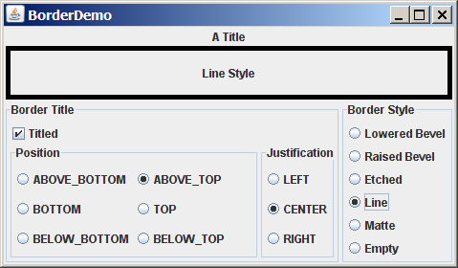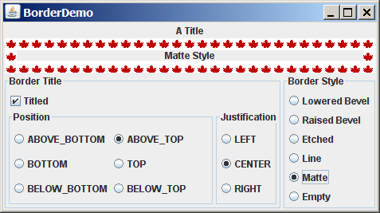
(a) (b)

Figure 37.20
The program demonstrates various types of borders.
Here are the major steps in the program:

1. Create the user interface.
  - Create a JLabel object and place it in the center of the frame.
  - Create a panel named jpPositon to group the radio buttons for selecting the border title position. Set the border of this panel in the titled border with the title “Position”.
  - Create a panel named jpJustification to group the radio buttons for selecting the border title justification. Set the border of this panel in the titled border with the title “Justification”.
  - Create a panel named jpTitleOptions to hold the jpPosition panel and the jpJustification panel.
  - Create a panel named jpTitle to hold a check box named “Titled” and the jpTitleOptions panel.
  - Create a panel named jpBorderStyle to group the radio buttons for selecting border styles.
  - Create a panel named jpAllChoices to hold the panels jpTitle and jpBorderStyle. Place jpAllChoices in the south of the frame.

2. Process the event.
Create and register listeners to implement the actionPerformed handler to set the border for the label according to the events from the check box, and from all the radio buttons.

Listing 37.9 BorderDemo.java
<margin note line 30: create UI>
<margin note line 142: empty border>
<margin note line 145: bevel border>
<margin note line 149: bevel border>
<margin note line 153: etched border>
<margin note line 157: line border>
<margin note line 161: matte border>
<margin note line 167: empty border>
<margin note line 197: border on border>
<margin note line 207: main method omitted>

1 import java.awt.*;
2 import java.awt.event.ActionListener;
3 import java.awt.event.ActionEvent;
4 import javax.swing.*;
5 import javax.swing.border.*;
6
7 public class BorderDemo extends JApplet {
8 // Declare a label for displaying message
9 private JLabel jLabel1 = new JLabel("Display the border type",
10 JLabel.CENTER);
11
12 // A check box for selecting a border with or without a title
13 private JCheckBox jchkTitled;
14
15 // Radio buttons for border styles
16 private JRadioButton jrbLoweredBevel, jrbRaisedBevel,
17 jrbEtched, jrbLine, jrbMatte, jrbEmpty;
18
19 // Radio buttons for titled border options
20 private JRadioButton jrbAboveBottom, jrbBottom,
21 jrbBelowBottom, jrbAboveTop, jrbTop, jrbBelowTop,
22 jrbLeft, jrbCenter, jrbRight;
23
24 // TitledBorder for the label
25 private TitledBorder jLabel1Border;
26
27 /** Constructor */
28 public BorderDemo() {
29 // Create a JLabel instance and set colors
30 jLabel1.setBackground(Color.yellow);
31 jLabel1.setBorder(jLabel1Border);
32
33 // Place title position radio buttons
34 JPanel jpPosition = new JPanel();
35 jpPosition.setLayout(new GridLayout(3, 2));
36 jpPosition.add(
37 jrbAboveBottom = new JRadioButton("ABOVE_BOTTOM"));
38 jpPosition.add(jrbAboveTop = new JRadioButton("ABOVE_TOP"));
39 jpPosition.add(jrbBottom = new JRadioButton("BOTTOM"));
40 jpPosition.add(jrbTop = new JRadioButton("TOP"));
41 jpPosition.add(
42 jrbBelowBottom = new JRadioButton("BELOW_BOTTOM"));
43 jpPosition.add(jrbBelowTop = new JRadioButton("BELOW_TOP"));
44 jpPosition.setBorder(new TitledBorder("Position"));
45
46 // Place title justification radio buttons
47 JPanel jpJustification = new JPanel();
48 jpJustification.setLayout(new GridLayout(3,1));
49 jpJustification.add(jrbLeft = new JRadioButton("LEFT"));
50 jpJustification.add(jrbCenter = new JRadioButton("CENTER"));
51 jpJustification.add(jrbRight = new JRadioButton("RIGHT"));
52 jpJustification.setBorder(new TitledBorder("Justification"));
53
54 // Create panel jpTitleOptions to hold jpPosition and
55 // jpJustification
56 JPanel jpTitleOptions = new JPanel();
57 jpTitleOptions.setLayout(new BorderLayout());
58 jpTitleOptions.add(jpPosition, BorderLayout.CENTER);
59 jpTitleOptions.add(jpJustification, BorderLayout.EAST);
60
61 // Create Panel jpTitle to hold a check box and title position
62 // radio buttons, and title justification radio buttons
63 JPanel jpTitle = new JPanel();
64 jpTitle.setBorder(new TitledBorder("Border Title"));
65 jpTitle.setLayout(new BorderLayout());
66 jpTitle.add(jchkTitled = new JCheckBox("Titled"),
67 BorderLayout.NORTH);
68 jpTitle.add(jpTitleOptions, BorderLayout.CENTER);
69
70 // Group radio buttons for title position
71 ButtonGroup btgTitlePosition = new ButtonGroup();
72 btgTitlePosition.add(jrbAboveBottom);
73 btgTitlePosition.add(jrbBottom);
74 btgTitlePosition.add(jrbBelowBottom);
75 btgTitlePosition.add(jrbAboveTop);
76 btgTitlePosition.add(jrbTop);
77 btgTitlePosition.add(jrbBelowTop);
78
79 // Group radio buttons for title justification
80 ButtonGroup btgTitleJustification = new ButtonGroup();
81 btgTitleJustification.add(jrbLeft);
82 btgTitleJustification.add(jrbCenter);
83 btgTitleJustification.add(jrbRight);
84
85 // Create Panel jpBorderStyle to hold border style radio buttons
86 JPanel jpBorderStyle = new JPanel();
87 jpBorderStyle.setBorder(new TitledBorder("Border Style"));
88 jpBorderStyle.setLayout(new GridLayout(6, 1));
89 jpBorderStyle.add(jrbLoweredBevel =
90 new JRadioButton("Lowered Bevel"));
91 jpBorderStyle.add(jrbRaisedBevel =
92 new JRadioButton("Raised Bevel"));
93 jpBorderStyle.add(jrbEtched = new JRadioButton("Etched"));
94 jpBorderStyle.add(jrbLine = new JRadioButton("Line"));
95 jpBorderStyle.add(jrbMatte = new JRadioButton("Matte"));
96 jpBorderStyle.add(jrbEmpty = new JRadioButton("Empty"));
97
98 // Group radio buttons for border styles
99 ButtonGroup btgBorderStyle = new ButtonGroup();
100 btgBorderStyle.add(jrbLoweredBevel);
101 btgBorderStyle.add(jrbRaisedBevel);
102 btgBorderStyle.add(jrbEtched);
103 btgBorderStyle.add(jrbLine);
104 btgBorderStyle.add(jrbMatte);
105 btgBorderStyle.add(jrbEmpty);
106
107 // Create Panel jpAllChoices to place jpTitle and jpBorderStyle
108 JPanel jpAllChoices = new JPanel();
109 jpAllChoices.setLayout(new BorderLayout());
110 jpAllChoices.add(jpTitle, BorderLayout.CENTER);
111 jpAllChoices.add(jpBorderStyle, BorderLayout.EAST);
112
113 // Place panels in the frame
114 setLayout(new BorderLayout());
115 add(jLabel1, BorderLayout.CENTER);
116 add(jpAllChoices, BorderLayout.SOUTH);
117
118 // Register listeners
119 ActionListener listener = new EventListener();
120 jchkTitled.addActionListener(listener);
121 jrbAboveBottom.addActionListener(listener);
122 jrbBottom.addActionListener(listener);
123 jrbBelowBottom.addActionListener(listener);
124 jrbAboveTop.addActionListener(listener);
125 jrbTop.addActionListener(listener);
126 jrbBelowTop.addActionListener(listener);
127 jrbLeft.addActionListener(listener);
128 jrbCenter.addActionListener(listener);
129 jrbRight.addActionListener(listener);
130 jrbLoweredBevel.addActionListener(listener);
131 jrbRaisedBevel.addActionListener(listener);
132 jrbLine.addActionListener(listener);
133 jrbEtched.addActionListener(listener);
134 jrbMatte.addActionListener(listener);
135 jrbEmpty.addActionListener(listener);
136 }
137
138 private class EventListener implements ActionListener {
139 @Override /** Handle ActionEvents on check box and radio buttons */
140 public void actionPerformed(ActionEvent e) {
141 // Get border style
142 Border border = new EmptyBorder(2, 2, 2, 2);
143
144 if (jrbLoweredBevel.isSelected()) {
145 border = new BevelBorder(BevelBorder.LOWERED);
146 jLabel1.setText("Lowered Bevel Style");
147 }
148 else if (jrbRaisedBevel.isSelected()) {
149 border = new BevelBorder(BevelBorder.RAISED);
150 jLabel1.setText("Raised Bevel Style");
151 }
152 else if (jrbEtched.isSelected()) {
153 border = new EtchedBorder();
154 jLabel1.setText("Etched Style");
155 }
156 else if (jrbLine.isSelected()) {
157 border = new LineBorder(Color.black, 5);
158 jLabel1.setText("Line Style");
159 }
160 else if (jrbMatte.isSelected()) {
161 border = new MatteBorder(15, 15, 15, 15,
162 new ImageIcon(getClass().getResource
163 ("/image/caIcon.gif")));
164 jLabel1.setText("Matte Style");
165 }
166 else if (jrbEmpty.isSelected()) {
167 border = new EmptyBorder(2, 2, 2, 2);
168 jLabel1.setText("Empty Style");
169 }
170
171 if (jchkTitled.isSelected()) {
172 // Get the title position and justification
173 int titlePosition = TitledBorder.DEFAULT_POSITION;
174 int titleJustification = TitledBorder.DEFAULT_JUSTIFICATION;
175
176 if (jrbAboveBottom.isSelected())
177 titlePosition = TitledBorder.ABOVE_BOTTOM;
178 else if (jrbBottom.isSelected())
179 titlePosition = TitledBorder.BOTTOM;
180 else if (jrbBelowBottom.isSelected())
181 titlePosition = TitledBorder.BELOW_BOTTOM;
182 else if (jrbAboveTop.isSelected())
183 titlePosition = TitledBorder.ABOVE_TOP;
184 else if (jrbTop.isSelected())
185 titlePosition = TitledBorder.TOP;
186 else if (jrbBelowTop.isSelected())
187 titlePosition = TitledBorder.BELOW_TOP;
188
189 if (jrbLeft.isSelected())
190 titleJustification = TitledBorder.LEFT;
191 else if (jrbCenter.isSelected())
192 titleJustification = TitledBorder.CENTER;
193 else if (jrbRight.isSelected())
194 titleJustification = TitledBorder.RIGHT;
195
196 jLabel1Border = new TitledBorder("A Title");
197 jLabel1Border.setBorder(border);
198 jLabel1Border.setTitlePosition(titlePosition);
199 jLabel1Border.setTitleJustification(titleJustification);
200 jLabel1.setBorder(jLabel1Border);
201 }
202 else {
203 jLabel1.setBorder(border);
204 }
205 }
206 }
207 }

This example uses many panels to group UI components to achieve the desired look. Figure 37.20 illustrates the relationship of the panels. The Border Title panel groups all the options for setting title properties. The position options are grouped in the Position panel. The justification options are grouped in the Justification panel. The Border Style panel groups the radio buttons for choosing Lowered Bevel, Raised Bevel, Etched, Line, Matte, and Empty borders.

The label displays the selected border with or without a title, depending on the selection of the title check box. The label also displays a text indicating which type of border is being used, depending on the selection of the radio button in the Border Style panel.

The TitledBorder can be mixed with other borders. To do so, simply create an instance of TitledBorder, and use the setBorder method to embed a new border in TitledBorder.

The MatteBorder can be used to display icons on the border, as shown in Figure 37.20b.

Chapter Summary
- javax.swing.JRootPane is a lightweight container used behind the scenes by Swing's top-level containers, such as JFrame, JApplet, and JDialog. javax.swing.JLayeredPane is a container that manages the optional menu bar and the content pane. The content pane is an instance of Container. By default, it is a JPanel with BorderLayout. This is the container where the user interface components are added. To obtain the content pane in a JFrame or in a JApplet, use the getContentPane() method. You can set any instance of Container to be a new content pane using the setContentPane method.
- Every container has a layout manager that is responsible for arranging its components. The container's setLayout method can be used to set a layout manager. Certain types of containers have default layout managers.
- The layout manager places the components in accordance with its own rules and property settings, and with the constraints associated with each component. Every layout manager has its own specific set of rules. Some layout managers have properties that can affect the sizing and location of the components in the container.
- Java also supports absolute layout, which enables you to place components at fixed locations. In this case, the component must be placed using the component's instance method setBounds() (defined in java.awt.Component). Absolute positions and sizes are fine if the application is developed and deployed on the same platform, but what looks fine on a development system may not look right on a deployment system on a different platform. To solve this problem, Java provides a set of layout managers that place components in containers in a way that is independent of fonts, screen resolutions, and operating systems.
- In addition to the layout managers provided in Java, you can create custom layout managers by implementing the LayoutManager interface.
- Java provides specialized containers Box, JScrollPane, JTabbedPane, and JSplitPane with fixed layout managers.
- A Swing border is defined in the Border interface. Every instance of JComponent can set a border through the border property defined in JComponent. If a border is present, it replaces the inset. There are eight concrete border classes: BevelBorder, SoftBevelBorder, CompoundBorder, EmptyBorder, EtchedBorder, LineBorder, MatteBorder, and TitledBorder. You can use the constructors of these classes or the static methods in javax.swing.BorderFactory to create borders.

Test Questions
Do the test questions for this chapter online at www.cs.armstrong.edu/liang/intro9e/test.html.

Review Questions

Section 37.2
37.1 Since JButton is a subclass of Container, can you add a button inside a button?
37.2 How do you set an image icon in a JFrame’s title bar? Can you set an image icon in a JApplet’s title bar?
37.3 Which of the following are the properties in JFrame, JApplet, and JPanel?
contentPane, iconImage, jMenuBar, resizable, title

Section 37.3
37.4 How does the layout in Java differ from those in Visual Basic?
37.5 Discuss the factors that determine the size of the components in a container.
37.6 Discuss the properties preferredSize, minimumSize, and maximumSize.
37.7 Discuss the properties alignmentX and alignmentY.
37.8 What is a CardLayout manager? How do you create a CardLayout manager?
37.9 Can you use absolute positioning in Java? How do you use absolute positioning? Why should you avoid using it?
37.10 What is BoxLayout? How do you use BoxLayout? How do you use fillers to separate the components?

Sections 37.4-37.7
37.11 How do you create a custom layout manager?
37.12 What is JScrollPane? How do you use JScrollPane?
37.13 What is JTabbedPane? How do you use JTabbedPane?
37.14 What is JSplitPane? How do you use JSplitPane?
37.15 Can you specify a layout manager in Box, JScrollPane, JTabbedPane, and JSplitPane?

Section 37.8 Swing Borders
37.16 How do you create a titled border, a line border, a bevel border, and an etched border?
37.17 Can you set a border for every Swing GUI component? Can a border object be shared by different GUI components?
37.18 What package contains Border, BevelBorder, CompoundBorder, EmptyBorder, EtchedBorder, LineBorder, MatteBorder, TitledBorder, and BorderFactory?

Programming Exercises

Section 37.3
37.1* (Demonstrate FlowLayout properties) Create a program that enables the user to set the properties of a FlowLayout manager dynamically, as shown in Figure 37.21. The FlowLayout manager is used to place 15 components in a panel. You can set the alignment, hgap, and vgap properties of the FlowLayout dynamically.
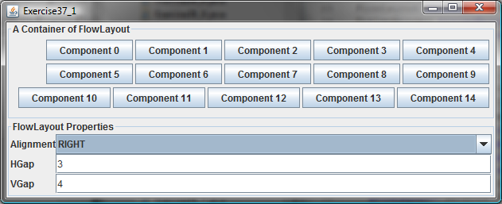

Figure 37.21
The program enables you to set the properties of a FlowLayout manager dynamically.
37.2* (Demonstrate GridLayout properties) Create a program that enables the user to set the properties of a GridLayout manager dynamically, as shown in Figure 37.22a. The GridLayout manager is used to place 15 components in a panel. You can set the rows, columns, hgap, and vgap properties of the GridLayout dynamically.
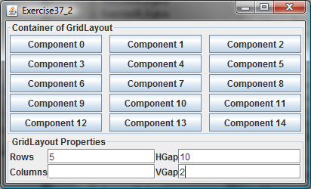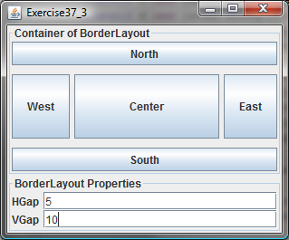
(a) (b)

Figure 37.22
(a) The program enables you to set the properties of a GridLayout manager dynamically. (b) The program enables you to set the properties of a BorderLayout manager dynamically.
37.3* (Demonstrate BorderLayout properties) Create a program that enables the user to set the properties of a BorderLayout manager dynamically, as shown in Figure 37.22b. The BorderLayout manager is used to place five components in a panel. You can set the hgap and vgap properties of the BorderLayout dynamically.
37.4* (Use CardLayout) Write an applet that does arithmetic on integers and rationals. The program uses two panels in a CardLayout manager, one for integer arithmetic and the other for rational arithmetic. The program provides a combo box with two items Integer and Rational. When the user chooses the Integer item, the integer panel is activated. When the user chooses the rational item, the rational panel is activated (see Figure 37.23).
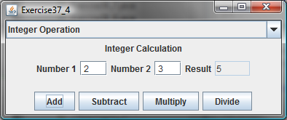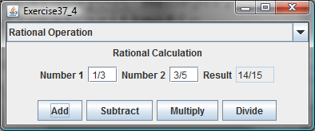

Figure 37.23
CardLayout is used to select panels that perform integer operations and rational number operations.
37.5* (Use null layout) Use absolute layout to lay out a calculator, as shown in Figure 18.18a.

Sections 37.4-37.8
37.6* (Use tabbed panes) Modify Listing 37.7, DisplayFigure.java, to add a panel of radio buttons for specifying the tab placement of the tabbed pane, as shown in Figure 37.24.
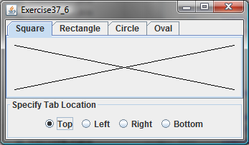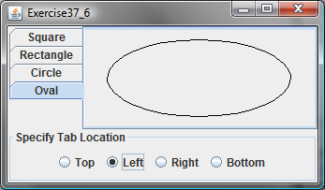

Figure 37.24
The radio buttons let you choose the tab placement of the tabbed pane.
37.7* (Use tabbed pane) Rewrite Exercise 37.4 using tabbed panes instead of CardLayout (see Figure 37.25).
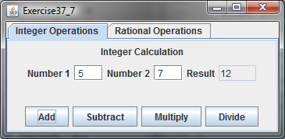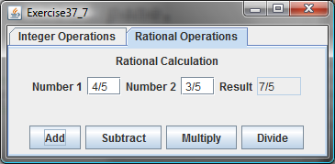

Figure 37.25
A tabbed pane is used to select panels that perform integer operations and rational number operations.
37.8* (Use JSplitPane) Create a program that displays four figures in split panes, as shown in Figure 37.26. Use the FigurePanel class defined in Listing 15.3, FigurePanel.java.
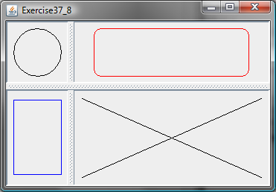

Figure 37.26
Four figures are displayed in split panes.
37.9* (Demonstrate JSplitPane properties) Create a program that enables the user to set the properties of a split pane dynamically, as shown in Figure 37.27.
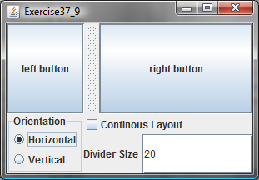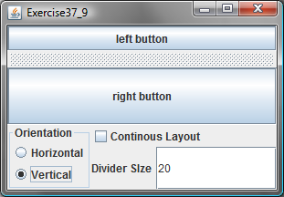

Figure 37.27
The program enables you to set the properties of a split pane dynamically.
37.10* (Demonstrate DiagonalLayout properties) Rewrite Listing 37.5 ShowDiagonalLayout.java to add a panel that show the properties of a DiagonalLayout. The panel disappears when the DiagonalLayout radio button is unchecked, and reappears when the DiagonalLayout radio button is checked, as shown in Figure 37.28.
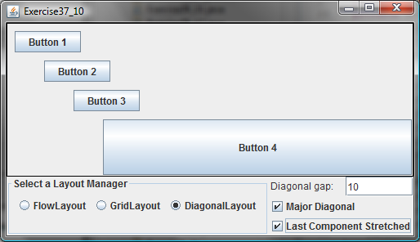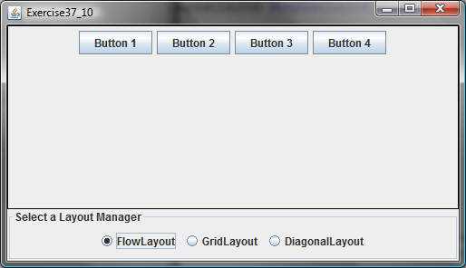

Figure 37.28
The program enables you to set the properties of the DiagonalLayout dynamically.

